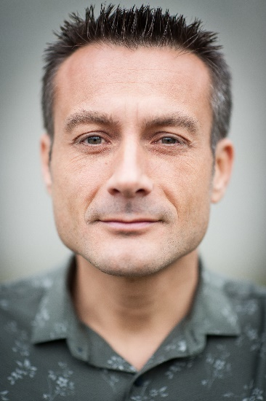
Mathieu Vinken is associate professor affiliated to the Free University Brussels-Belgium He has a background in pharmaceutical sciences, holds a doctoral degree in experimental in vitro toxicology and is a European Registered Toxicologist. He is President of the European Society of Toxicology In Vitro. He is author of more than 150 journal publications. He is associate editor of the journals Toxicology In Vitro and Archives of Toxicology, and European editor of the journal Applied In Vitro Toxicology.

